ETHICAL HACKING

1. systeminfo
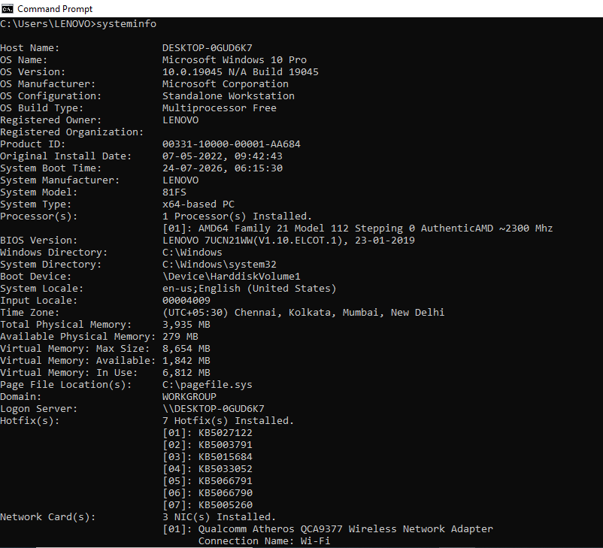
2. hostname
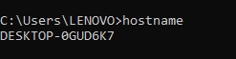

3. whoami /all
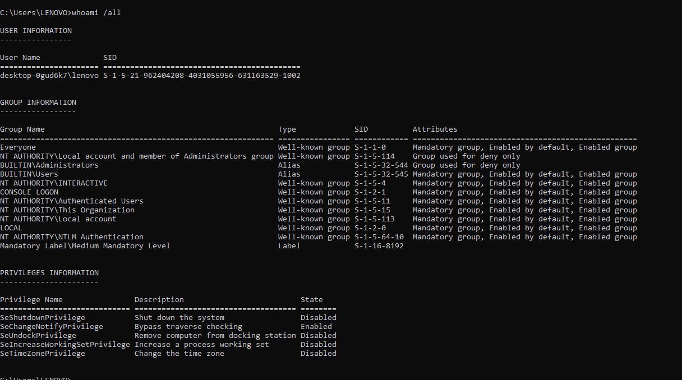
4. net user
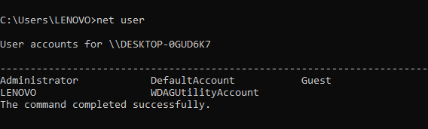
5. net localgroup administrators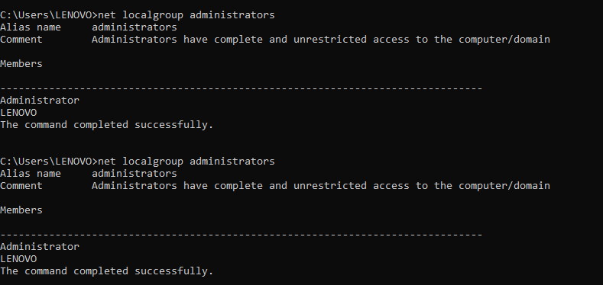

6. ipconfig /all
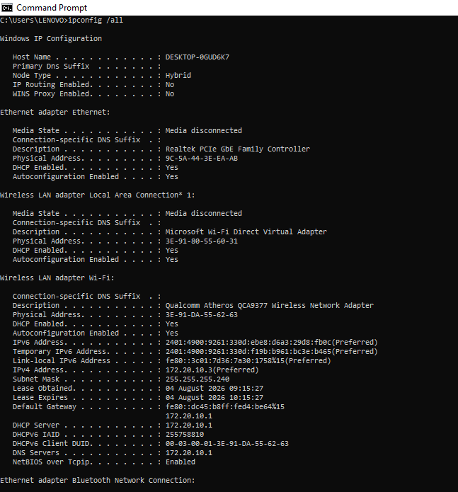
7. arp -a
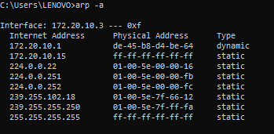

8. route print
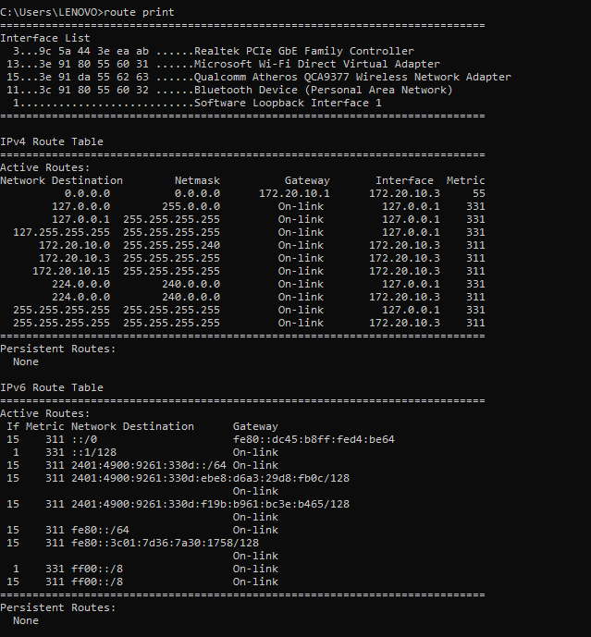

9. netstat -ano
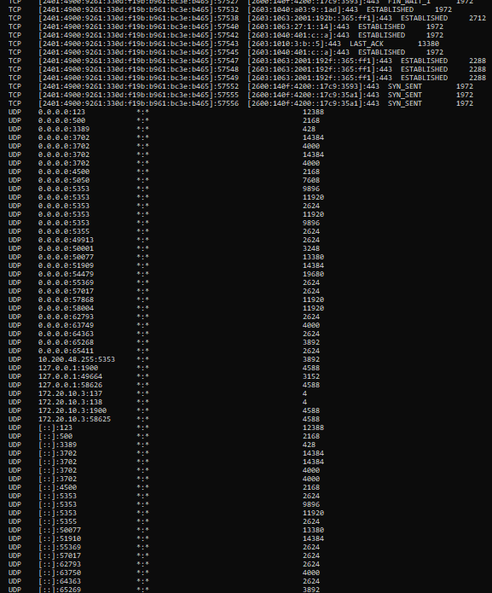
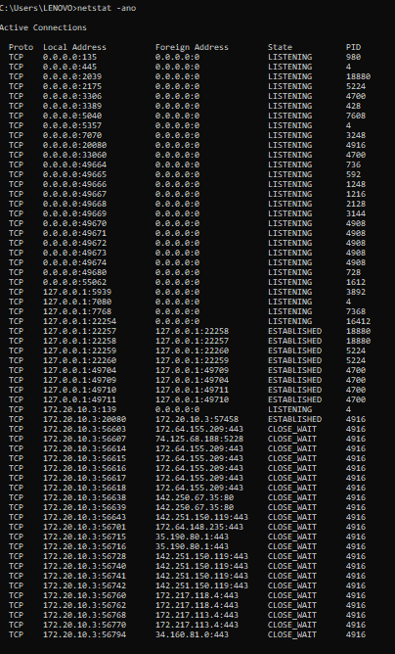

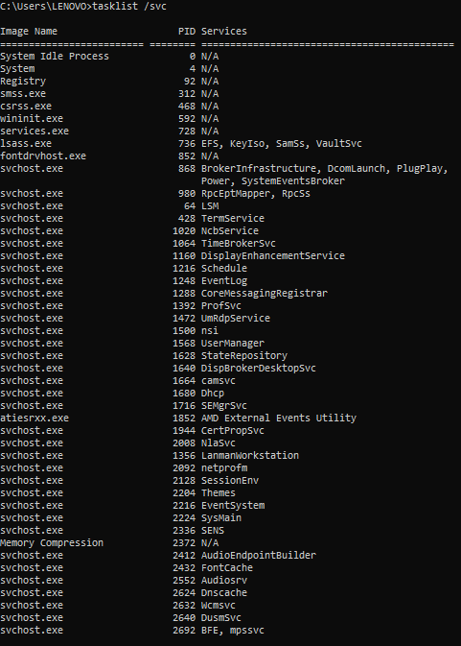
10. tasklist /svc
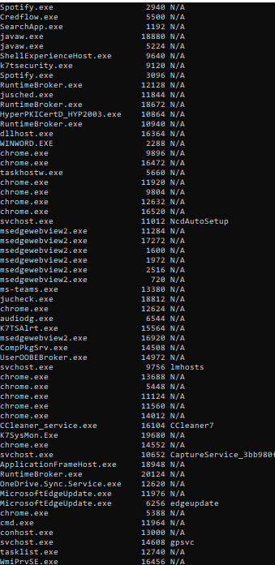

11. sc query
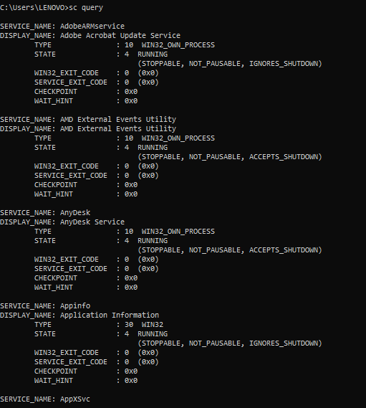
12. net share
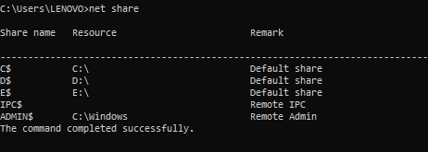
13. schtasks /query /fo LIST /v
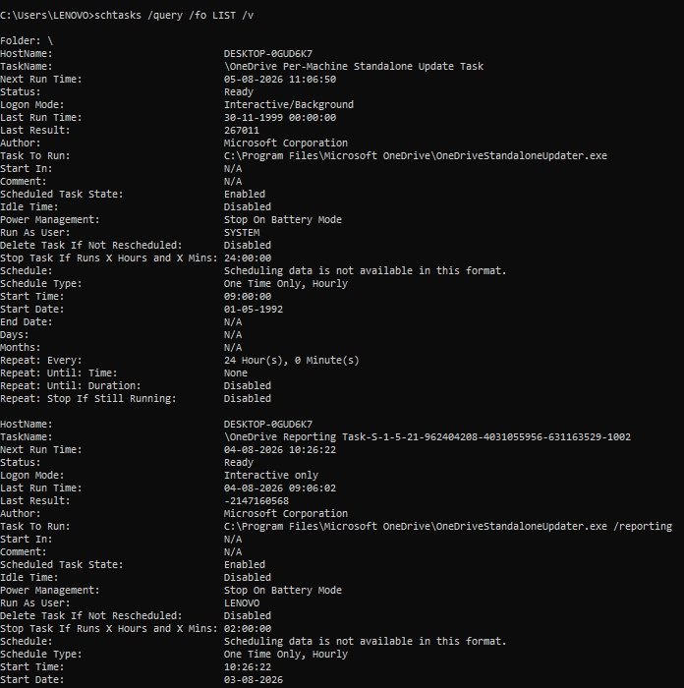
14. reg query HKLM\Software\Microsoft\Windows\CurrentVersion\Run
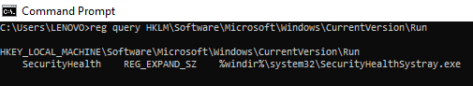

15. netsh advfirewall show allprofiles
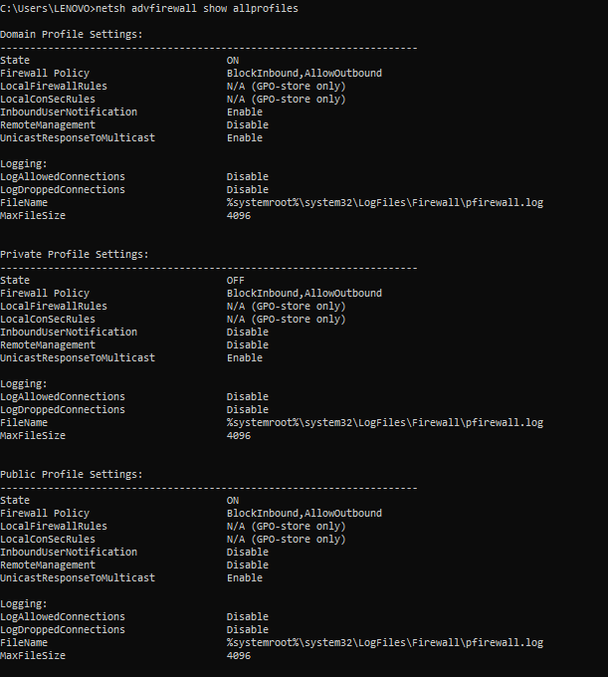
16. query user
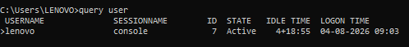
17.whoami
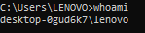
18.echo %computername%
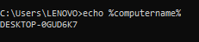
19. wmic bios get serialnumber
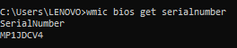
20. wmic csproduct get vendor,name
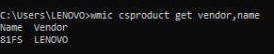
21. wmic cpu get name
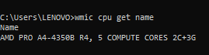
22. wmic memorychip get capacity,speed
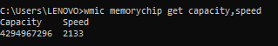
23. wmic computersystem get totalphysicalmemory
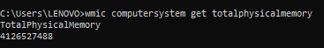
24.wmic path win32_videocontroller get name
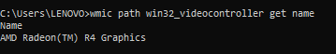
25.audio device speaker
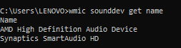
26.bios version
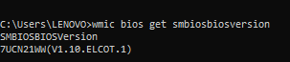

27. windows version
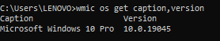
28. mac address
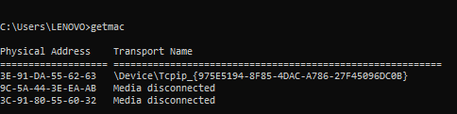
29. installed drivers
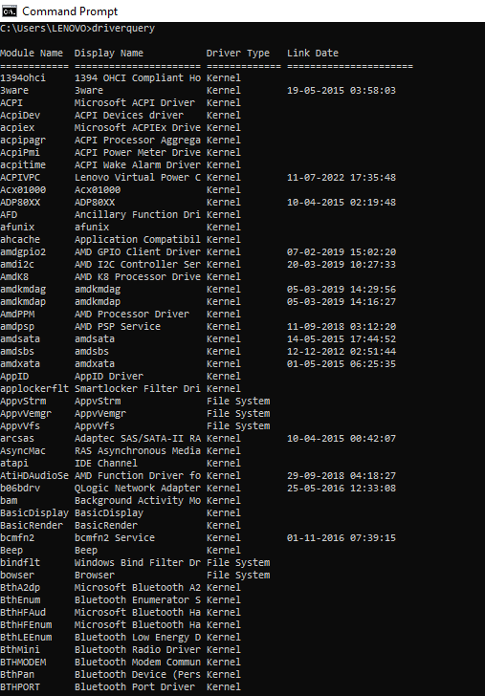
30.

30.trace network path
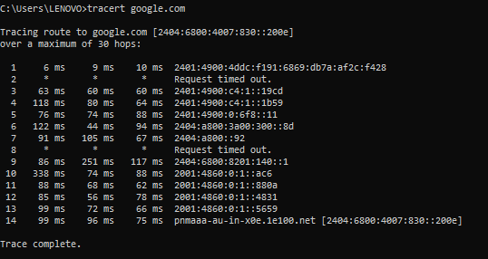
31. nslookup google.com
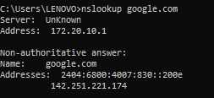

32. view DNS cache
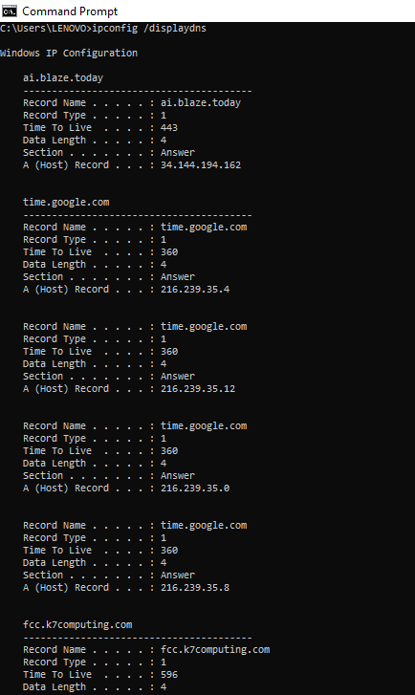
33.display firewall configuration
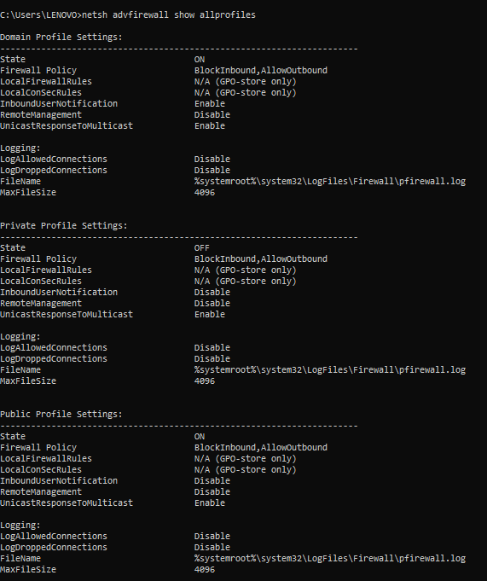
34. show wifi profiles
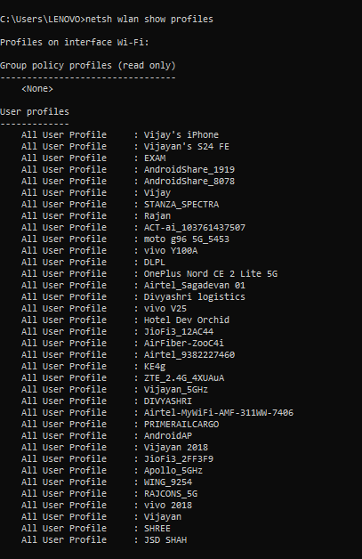
35.show current wifi connection
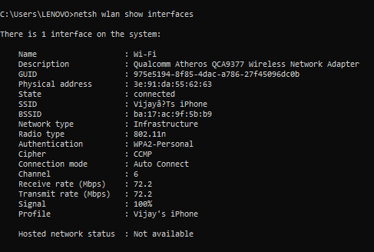
36. wmic diskdrive get model,serialnumber,size
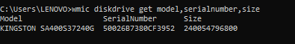
37. wmic sounddev get name,manufacturer,status
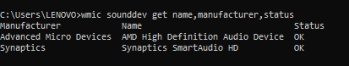
38. net localgroup
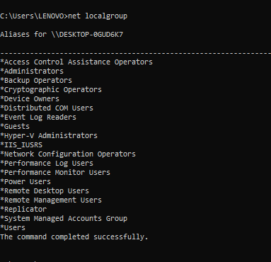
39.route print
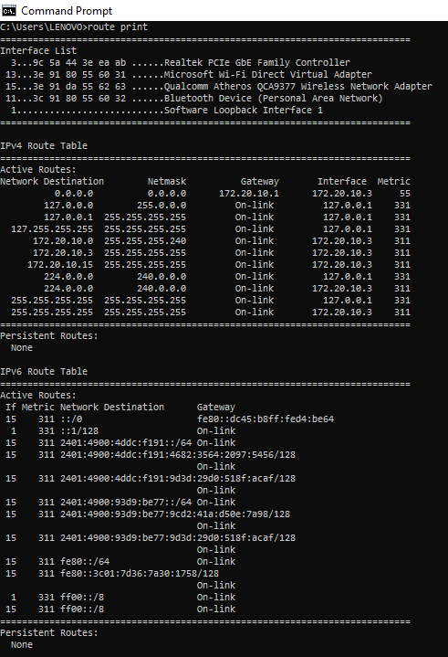
40. netstat -e
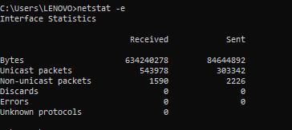
41.

